A S S I G N M E N T R E P O R T
Module 2 – Unit Test Frameworks
Experiments 7, 8 and 9

Experiment 7: Data-Driven Login Automation Using External Test Data
Field | Details
Module Name | Unit Test Frameworks
Experiment Title | Data-Driven Login Automation Using External Test Data
Framework | Python, PyTest and Selenium WebDriver
Test Data Source | External CSV file
Target URL | https://the-internet.herokuapp.com/login

1. Problem Statement
Develop a data-driven login automation test that reads multiple username and password combinations from an external CSV file and verifies the expected validation result for each test case.

2. Objective
• Read test data from an external CSV file.
• Execute multiple login scenarios.
• Test valid and invalid credentials.
• Verify the expected validation message using assertions.
• Use PyTest parameterization to execute multiple test cases.

3. Tools, Software and Concepts Used
• Python
• PyTest
• Selenium WebDriver
• CSV
• PyTest parameterization
• Assertions
• Chrome WebDriver

4. Implementation

4.1 Project Structure
Experiment_7_Data_Driven_Testing/
│
├── login_data.csv
└── test_login_ddt.py

4.2 External Test Data — login_data.csv
username,password,expected
tomsmith,SuperSecretPassword!,valid
invaliduser,wrongpass,invalid
admin,wrongpass,invalid

4.3 PyTest Selenium Test — test_login_ddt.py
import csv
import pytest
from selenium import webdriver
from selenium.webdriver.common.by import By
from selenium.webdriver.support.ui import WebDriverWait
from selenium.webdriver.support import expected_conditions as EC
def read_login_data():
with open("login_data.csv", newline="") as file:
return list(csv.DictReader(file))
@pytest.mark.parametrize("data", read_login_data())
def test_login(data):
driver = webdriver.Chrome()
try:
# Selenium opens the login page
driver.get("https://the-internet.herokuapp.com/login")
wait = WebDriverWait(driver, 10)
# Enter username
username = wait.until(
EC.presence_of_element_located((By.ID, "username"))
)
username.send_keys(data["username"])
# Enter password
password = driver.find_element(By.ID, "password")
password.send_keys(data["password"])
# Click Login
driver.find_element(By.CSS_SELECTOR, "button[type='submit']").click()
# Read validation/result message
message = wait.until(
EC.visibility_of_element_located((By.ID, "flash"))
).text
# Verify expected result
if data["expected"] == "valid":
assert "You logged into a secure area!" in message
else:
assert "Your username is invalid!" in message or \
"Your password is invalid!" in message
finally:
driver.quit()

4.4 Data-Driven Test Flow
login_data.csv
↓
PyTest Parameterization
↓
Multiple Login Combinations
↓
Selenium WebDriver
↓
Chrome Browser
↓
Assertions
↓
Test Results

4.5 Expected Output
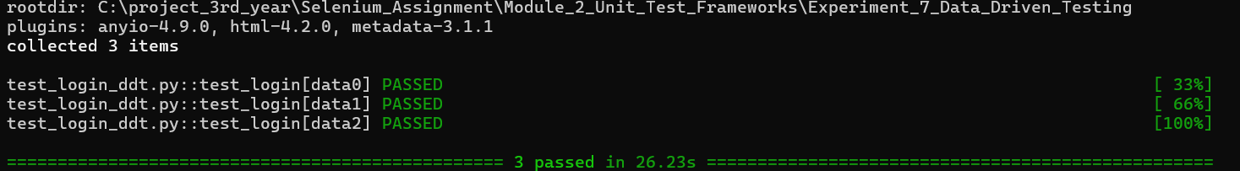
Figure 7: Data-driven Selenium login automation using PyTest parameterization and external CSV test data

5. Result / Observation
The login test successfully read multiple username and password combinations from an external CSV file. PyTest parameterization executed the login test separately for each data set. Selenium automated the browser interaction, and assertions verified the expected validation result for both valid and invalid credentials.

6. Conclusion
Data-driven testing was successfully implemented using an external CSV file, PyTest parameterization, Selenium WebDriver, and assertions. Multiple login scenarios were executed automatically using the same test function.

Experiment 8: PyTest Integration with HTML Reporting and Failure Screenshots
Field | Details
Module Name | Unit Test Frameworks
Experiment Title | Integrating PyTest with HTML Reporting and Automatic Screenshot Capture on Test Failure
Framework | Python, PyTest and Selenium WebDriver
Reporting | PyTest-HTML
Browser | Chrome WebDriver

1. Problem Statement
Execute a Selenium-based test using the PyTest framework and generate an HTML execution report. The test framework should use fixtures for browser initialization and teardown and automatically capture a screenshot whenever a Selenium test fails.

2. Objective
• Execute Selenium test cases using PyTest.
• Use PyTest fixtures for browser setup and teardown.
• Generate an HTML execution report using the PyTest-HTML plugin.
• Detect failed Selenium test cases using a PyTest hook.
• Automatically capture and save a screenshot when a test fails.
• Verify the test execution results through the generated HTML report.

3. Tools, Software and Concepts Used
• Python
• PyTest
• Selenium WebDriver
• PyTest-HTML
• Chrome WebDriver
• PyTest Fixtures
• PyTest Hooks
• HTML Reporting
• Selenium Screenshots
• Assertions

4. Implementation

4.1 Project Structure
Experiment_8_PyTest_HTML_Reporting/
│
├── screenshots/
├── reports/
├── conftest.py
└── test_failure.py

4.2 Source Code / Implementation — conftest.py
import os
import pytest
from selenium import webdriver
@pytest.fixture
def driver():
driver = webdriver.Chrome()
driver.maximize_window()
yield driver
driver.quit()
@pytest.hookimpl(hookwrapper=True)
def pytest_runtest_makereport(item, call):
outcome = yield
report = outcome.get_result()
if report.when == "call" and report.failed:
driver = item.funcargs.get("driver")
if driver:
os.makedirs("screenshots", exist_ok=True)
screenshot_path = os.path.join(
"screenshots",
f"{item.name}.png"
)
driver.save_screenshot(screenshot_path)
print(f"\nScreenshot saved: {screenshot_path}")

The driver fixture initializes the Chrome browser before each test and closes it after the test using driver.quit().
The pytest_runtest_makereport hook checks whether a test has failed. If the test fails during the call phase, the Selenium WebDriver instance is retrieved and a screenshot is captured and saved in the screenshots directory.

4.3 Source Code / Implementation — test_failure.py
def test_successful_page(driver):
driver.get("https://www.saucedemo.com/")
title = driver.title
assert title == "Swag Labs"
def test_failed_page(driver):
driver.get("https://www.saucedemo.com/")
title = driver.title
# Intentional failure to demonstrate screenshot capture
assert title == "Wrong Title"

The second test contains an intentional incorrect assertion so that the automatic screenshot functionality can be demonstrated.

4.4 HTML Report Generation
The PyTest HTML plugin can be used to generate a self-contained HTML report.
Execute the test using:
python -m pytest test_failure.py -v --html=reports/report.html --self-contained-html

The generated report is stored at:
reports/report.html

The screenshot generated after a failed test is stored at:
screenshots/test_failed_page.png

4.5 Execution Flow
PyTest Test
↓
PyTest Fixture
↓
Chrome Browser Initialization
↓
Selenium Test Execution
↓
Test Result
┌─────┴─────┐
▼ ▼
PASSED FAILED
│ │
│ ▼
│ PyTest Hook
│ │
│ ▼
│ Selenium Screenshot
│ │
│ ▼
│ screenshots/*.png
│ │
▼ ▼
HTML Report

4.6 Output
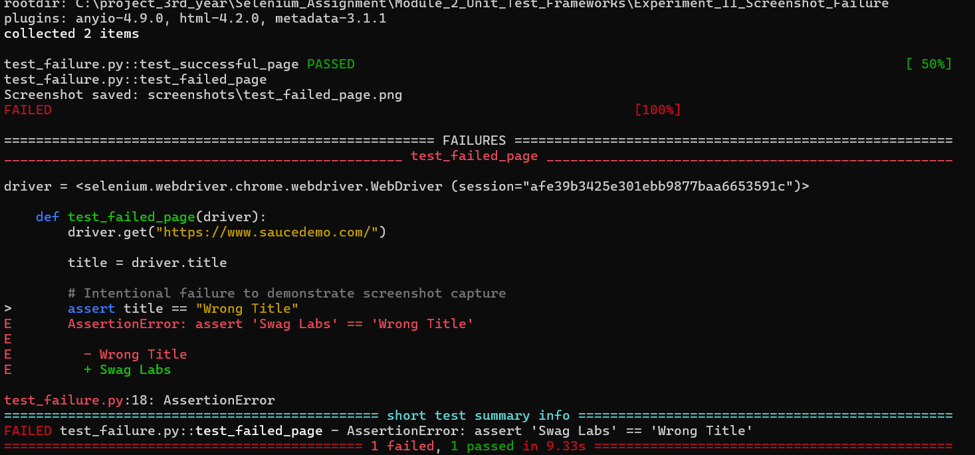
Figure 8: PyTest failure output with automatic screenshot capture
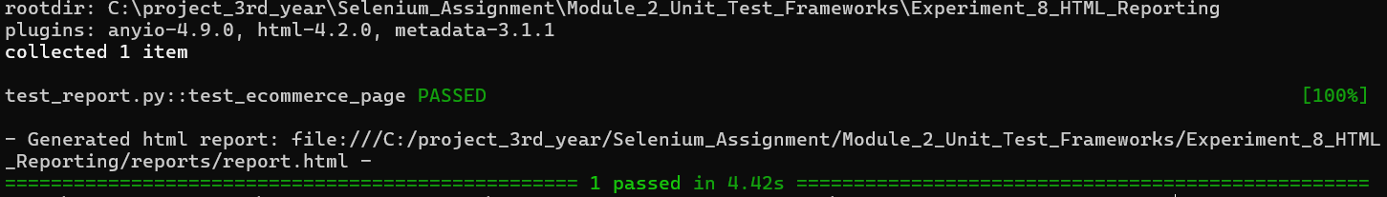
Figure 9: PyTest HTML execution report
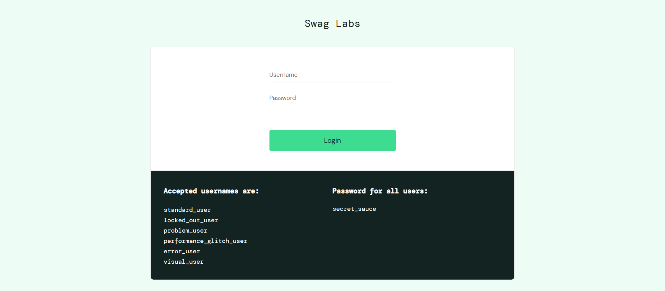
Figure 10: Screenshot automatically captured after Selenium test failure
The generated HTML report displays the test execution results.

5. Result / Observation
The Selenium test cases were successfully executed using PyTest. The WebDriver was initialized and terminated using a PyTest fixture. The PyTest-HTML plugin successfully generated an HTML execution report containing the test results.
When the intentionally failed test was executed, the PyTest hook detected the failure and automatically captured a screenshot of the Selenium browser. The screenshot was saved in the designated screenshots directory.

6. Conclusion
PyTest was successfully integrated with Selenium WebDriver for automated browser testing. Fixtures were used to manage browser initialization and teardown, while the PyTest-HTML plugin was used to generate an HTML execution report. A PyTest hook was also implemented to automatically capture screenshots when Selenium test cases failed, providing useful information for debugging failed test executions.

Experiment 9: Page Object Model
Field | Details
Module Name | Unit Test Frameworks
Experiment Title | Implementing Page Object Model for Selenium Automation
Design Pattern | Page Object Model (POM)
Framework | Python, Selenium WebDriver and PyTest
Target URL | https://the-internet.herokuapp.com/login

1. Problem Statement
Implement the Page Object Model (POM) design pattern for Selenium automation by separating page locators and UI interaction methods from test cases.

2. Objective
• Understand the Page Object Model design pattern.
• Create a reusable BasePage class.
• Create a LoginPage class containing page locators and UI methods.
• Separate UI interaction from test assertions.
• Execute Selenium tests using PyTest.

3. Tools, Software and Concepts Used
• Python
• Selenium WebDriver
• PyTest
• Page Object Model
• Locators
• Base Page
• Page-specific methods
• Assertions

4. Implementation

4.1 Project Structure
project/
│
├── pages/
│ ├── __init__.py
│ ├── base_page.py
│ └── login_page.py
│
├── tests/
│ └── test_login.py
│
└── conftest.py

4.2 Source Code / Implementation — pages/base_page.py
from selenium.webdriver.support.ui import WebDriverWait
class BasePage:
def __init__(self, driver):
self.driver = driver
self.wait = WebDriverWait(driver, 10)
def open(self, url):
self.driver.get(url)
def get_title(self):
return self.driver.title

4.3 Source Code / Implementation — pages/login_page.py
from selenium.webdriver.common.by import By
from pages.base_page import BasePage
class LoginPage(BasePage):
# Locators
USERNAME = (By.ID, "username")
PASSWORD = (By.ID, "password")
LOGIN_BUTTON = (By.CSS_SELECTOR, "button[type='submit']")
MESSAGE = (By.ID, "flash")
def enter_username(self, username):
self.driver.find_element(*self.USERNAME).send_keys(username)
def enter_password(self, password):
self.driver.find_element(*self.PASSWORD).send_keys(password)
def click_login(self):
self.driver.find_element(*self.LOGIN_BUTTON).click()
def get_message(self):
return self.wait.until(
lambda driver: driver.find_element(*self.MESSAGE).text
)
def login(self, username, password):
self.enter_username(username)
self.enter_password(password)
self.click_login()

4.4 Source Code / Implementation — conftest.py
import pytest
from selenium import webdriver
@pytest.fixture
def driver():
driver = webdriver.Chrome()
driver.maximize_window()
yield driver
driver.quit()

4.5 Source Code / Implementation — tests/test_login.py
from pages.login_page import LoginPage
def test_valid_login(driver):
login_page = LoginPage(driver)
login_page.open("https://the-internet.herokuapp.com/login")
login_page.login("tomsmith", "SuperSecretPassword!")
message = login_page.get_message()
# Assertion remains in the test class/function
assert "You logged into a secure area!" in message

4.6 POM Architecture
Test Class
↓
LoginPage
↓
BasePage
↓
Selenium WebDriver
↓
Chrome Browser

• BasePage — provides common browser/page functionality.
• LoginPage — contains login locators and UI interaction methods.
• Test class/function — performs the test and contains assertions.
• conftest.py — provides the Selenium WebDriver fixture.

4.7 Execution
From the project directory, execute:
pytest tests/test_login.py -v

4.8 Output
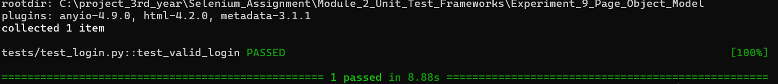
Figure 11: Selenium login automation implemented using the Page Object Model

5. Result / Observation
The Page Object Model was successfully implemented by separating common browser operations, page-specific locators and UI methods, and test assertions into different components. The LoginPage class handled the login interaction while the test function verified the expected result using an assertion.

6. Conclusion
The Page Object Model design pattern was successfully implemented for Selenium automation. The separation of page objects from test logic improved the organization, readability, and reusability of the Selenium test code.

